Signal Processing

**Continuous functions**

**What：**

连续变量函数

**Why:**

拍照，录音，CT等领域

**How:**

采样与重建

**Aliasing**

**What:**

混叠：对模拟信号进行抽样，当抽样频率小于信号最大频率2倍时，不满足奈奎斯特采样定律，信号在频域会产生混叠效应。

**Why:**

高频信号会被误采样为低频信号。

**How:**

提高采样频率。

**Filter**

**What:**

**Why:**

To avoid these undersampling artifacts the digital audio recorder filters the input to the ADC to remove high frequencies that can cause problems.

To remove this reconstruction artifact, the digital audio player filters the output from the DAC to smooth out the waveform.

**How:**

**Artifacts**

**What:**

在图形学里，artifacts泛指一些不准确或者与我们预期不一样的结果。

**Why:**

A concrete example of the kind of artifacts that can arise from too-low sample frequencies.

**How:**

To avoid these **undersampling artifacts** the digital audio recorder filters the input to the ADC to remove high frequencies that can cause problems.

To remove this **reconstruction artifact**, the digital audio player filters the output from the DAC to smooth out the waveform.

The basic issues of sampling and reconstruction can be understood simplybased on features being too small or too large, but some more quantitative questions are harder to answer:

• What sample rate is high enough to ensure good results?

• What kinds of filters are appropriate for sampling and reconstruction?

• What degree of smoothing is required to avoid aliasing?

**Convolution**

**What:**

卷积是通过两个函数f和g 生成第三个函数的一种数学算子，表征函数f与g经过翻转和平移的重叠部分函数值乘积对重叠长度的积分。

**Why:**

用于采样，滤波和重建。

**How:**

**Discrete Convolution**：

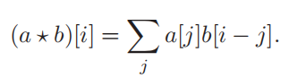

b[i−j] gives the weight for the sample at position j.

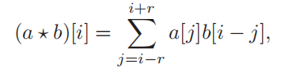

If we assume that b has finite support, there is some radius r such that b[k]=0 whenever |k| > r. In that case, we can write the sum above as.

**Properties of Convolution**

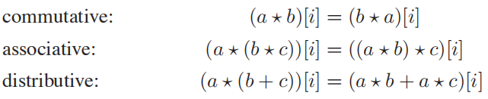

**Moving Averages**

**What:**

为了在任何一点得到平滑值，我们计算函数在每个方向上延伸距离r的范围内的平均值。距离r称为平滑操作的半径。

**Why:**

移动平均线的概念是卷积的精髓;唯一的区别是在卷积中移动平均线是一个加权平均线。

**How:**

continuous function：

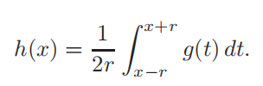

discrete function：

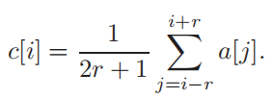

**Box filter**

**What:**

在其为非零的区间内具有一个常数值的过滤器。

**Why:**

**How:**

